(a) Please see attached codes

(b) Market beta rank: Top 5

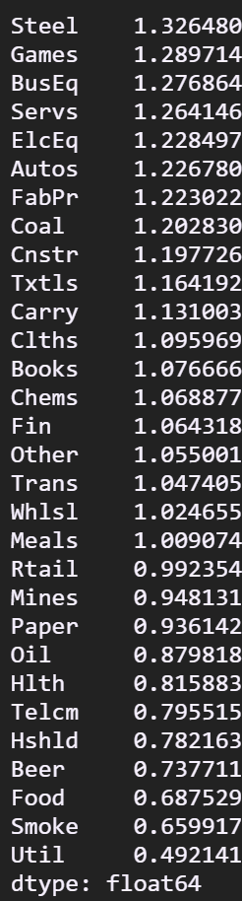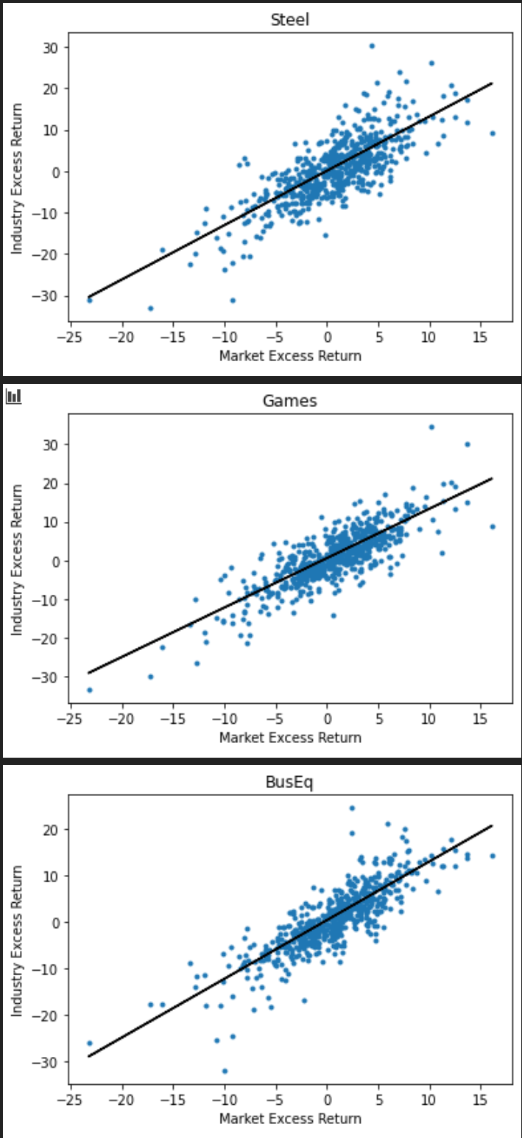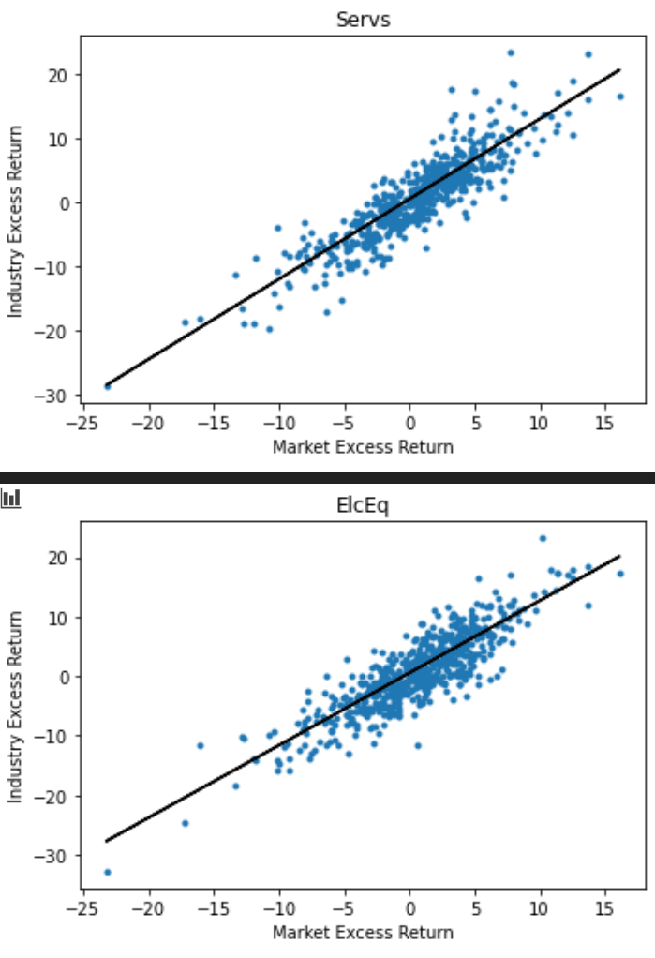

Bottom 5:

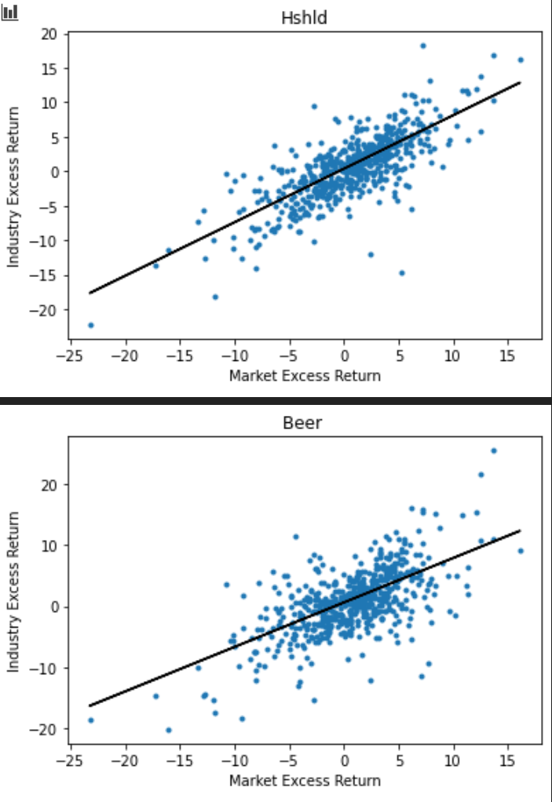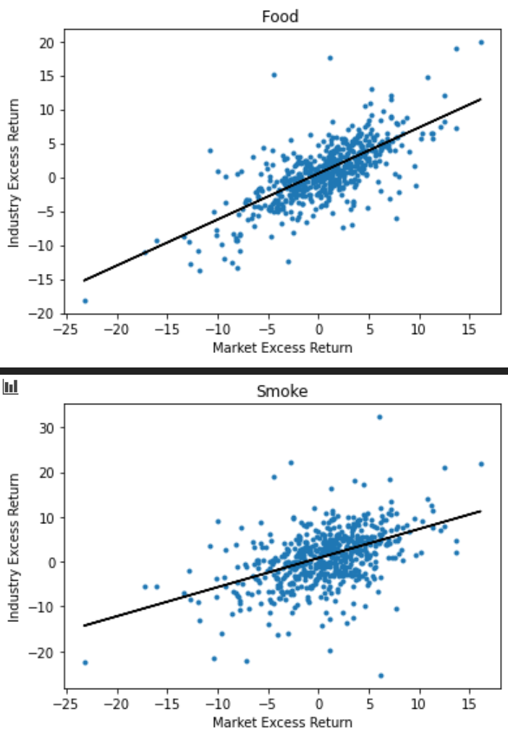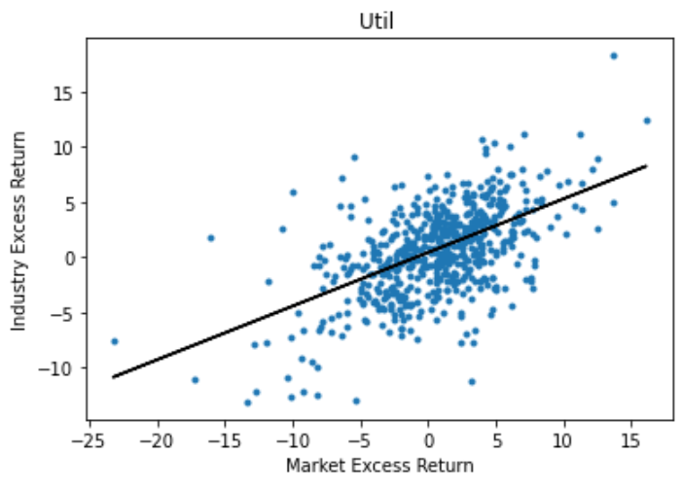

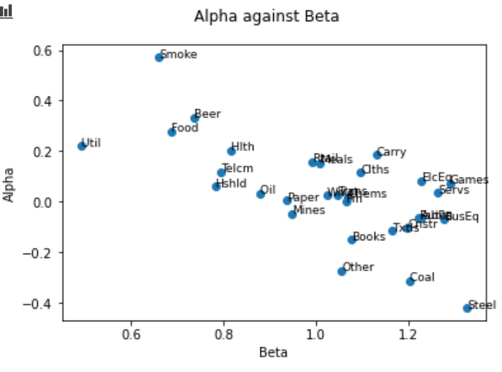

Alpha and Beta seems to be negatively correlated: industries with higher beta seems to have smaller and negative alpha.

(c)

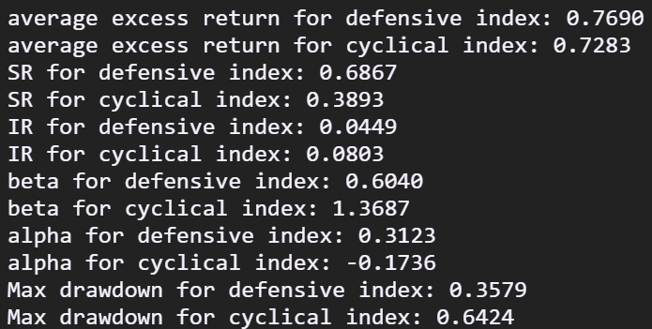

Comments: defensive portfolio outperforms cyclical portfolio significantly in almost all these measures. Investing in industries with smaller beta makes sense.

(d)

Using the better-performing Bayesian method with alpha = 10 (which result in more “sensible” and narrower-ranging weights), and regard cyclical index as “market index” and defensive index as “risk-free investment” in the original setup, we have the performance as below:

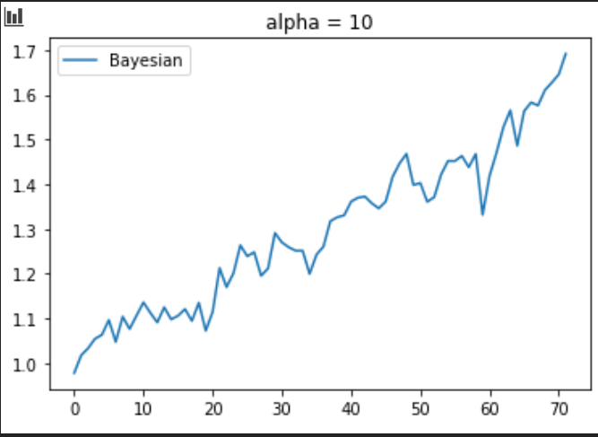

Which is better compared with pset1:

